Smart Village Dashboard: Intelligence Platform for Rural Governance

Harsh Kumar
Master of Computer Applications Lovely Professional University Punjab, India harsh832019@gmail.com

Khush Mohammad
Divyanshu
Master of Computer Applications Lovely Professional University Punjab, India devdivyanshuvarshney@gmail.com

Rahul Pandit
Mohd Saad
Master of Computer Applications Lovely Professional University Punjab, India saadgufran068@gmail.com

Master of Computer Applications Lovely Professional University Punjab, India khushmohd151@gmail.com
Master of Computer Applications Lovely Professional University Punjab, India rpandit6566@gmail.com

Abstract—This paper presents the design and implementation of the Smart Village Dashboard, a comprehensive web-based governance intelligence platform. The system follows a four- layer architecture comprising a static HTML shell, a React- based frontend, an Express backend with RESTful APIs, and a MongoDB persistence layer. Key functionalities include role- based authentication, village intelligence management, real-time environmental data integration (weather, air quality, geocoding), administrative content controls, citizen grievance submission, and an AI-powered assistant. The platform enables seamless data propagation from admin updates to all consumer pages including landing, analytics, growth, search, and village detail views. A reusable component library ensures maintainability across the codebase. The application was developed by a team of five members with distinct responsibilities spanning frontend devel- opment, backend engineering, database design, API integration, and UI/UX implementation.
Index Terms—smart village, governance dashboard, rural in- telligence, React, Express, MongoDB, REST API, environmental monitoring, team development

- Introduction
Modern rural governance requires data-driven decision sup- port systems that integrate village intelligence, environmental monitoring, and citizen engagement. Traditional approaches rely on isolated data silos and manual reporting, leading to delayed responses and inefficient resource allocation [1]. The Smart Village Dashboard presented in this paper addresses these challenges through a unified web-based platform.
- Team Composition
The project was developed by a team of five Master of Computer Applications students at Panjab University, India. The team members and their primary responsibilities are as follows:
  - Harsh Kumar: Backend development including Express server setup, API route creation, authentication logic, and JWT implementation.
  - Divyanshu: Frontend core development including React architecture, routing configuration, and Context providers (AuthContext, DataContext).
  - Mohd Saad: Database design including MongoDB schema creation, Mongoose models, and data seeding.
  - Khush Mohammad: External API integration for weather forecasting, air quality index, and geocoding services.
  - Rahul Pandit: UI/UX implementation including reusable components, dark/light mode theming, and AI assistant widget.
- Primary Contributions
The main contributions of this work are:
- A four-layer software architecture separating presenta- tion, UI components, application logic, and data persis- tence.
- A role-based authentication mechanism with JSON Web Token (JWT) storage.
- Integration of three external environmental APIs for location search, weather forecasting, and air quality monitoring.
- A reusable component library that reduces code dupli- cation across the codebase.
- An AI-powered assistant widget providing page-specific contextual guidance.
- System Architecture
The application is organized into four distinct layers as illustrated in Fig. 1. Each layer communicates only with adjacent layers, ensuring loose coupling and maintainability.
- Layer 1: HTML Shell
The file index.html serves as the static entry point containing a div element with identifier #root. This element acts as the mounting target for the React component tree.

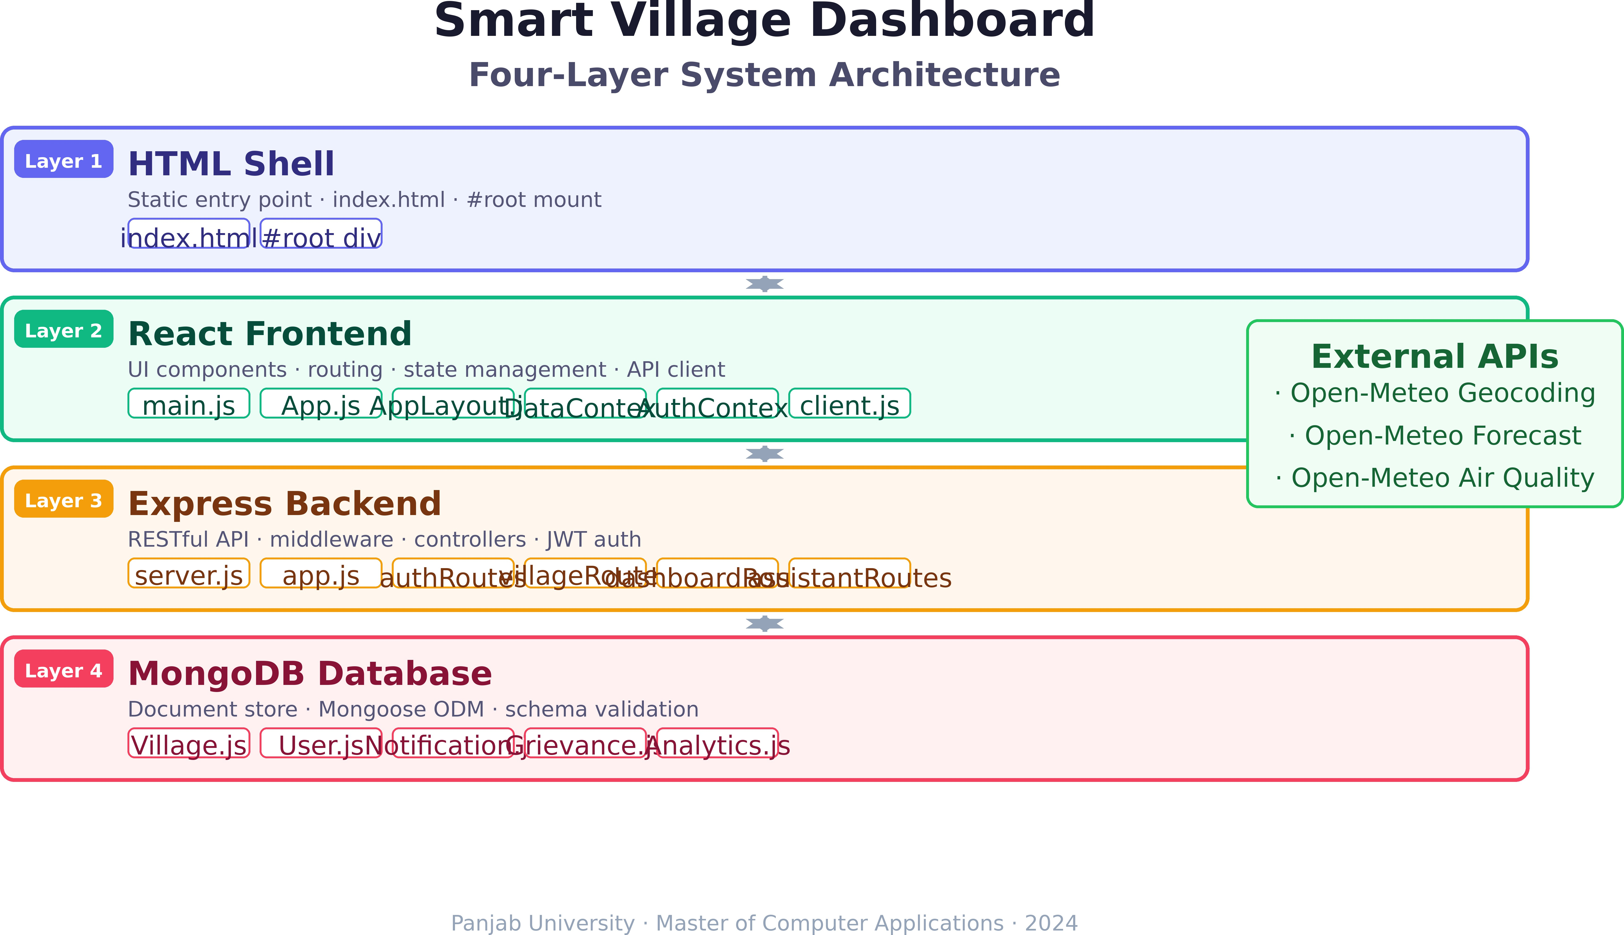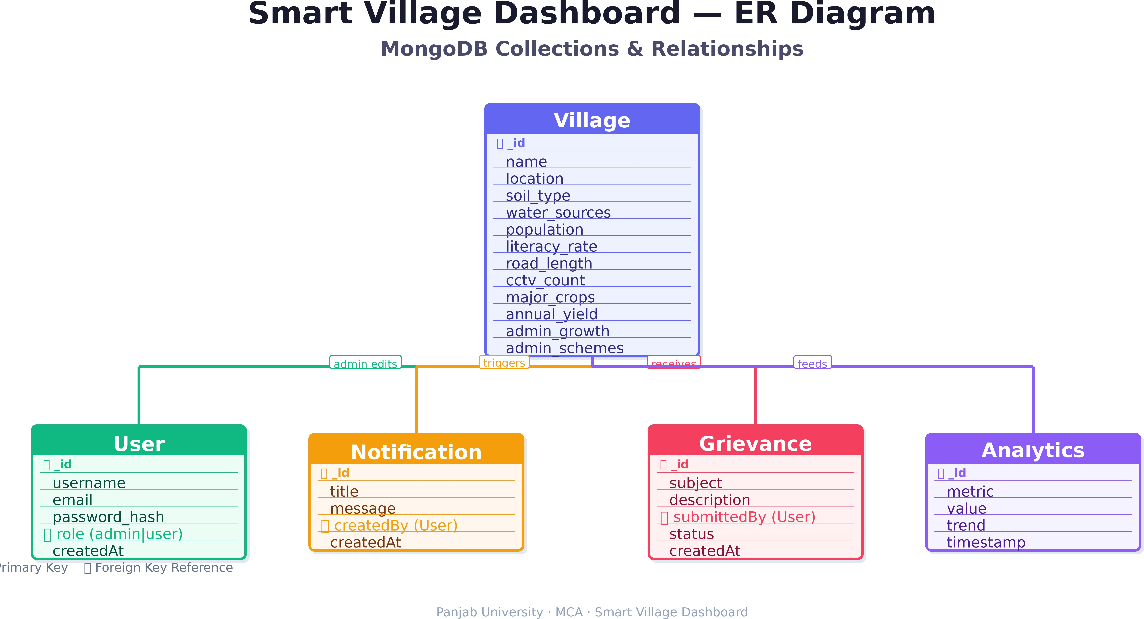

Fig. 1. Four-layer system architecture of the Smart Village Dashboard (Layer 1: HTML Shell, Layer 2: React Frontend, Layer 3: Express Backend, Layer 4: MongoDB Database).

- Layer 2: React Frontend
The frontend subsystem comprises multiple JavaScript mod- ules. main.js initializes the React application and mounts it into #root. App.js defines all application routes and wraps the component tree with context providers. AppLayout.js renders the persistent UI skeleton including header, footer, authentication modal, assistant widget, and notification banner.
- Layer 3: Express Backend
The backend is built using the Express framework for Node.js. server.js initializes the HTTP server, establishes database connectivity, and seeds default records. app.js configures middleware components (CORS, JSON parsing, URL encoding) and mounts all API route modules.
- Layer 4: MongoDB Database
MongoDB serves as the persistent document store. The Mongoose object data modeling library provides schema val- idation. The primary schema, Village.js, stores village identity, soil composition, water resources, literacy metrics, technology adoption indicators, CCTV deployment, weather metadata, and admin-editable fields.
- Database Schema (ER Diagram)
The database schema revolves around the Village entity as the core document. Fig. 2 presents the Entity-Relationship diagram showing all collections and their relationships.
- Primary Schema: Village.js
The Village collection serves as the central intelligence store with the following fields:
  - Identity: village name, location coordinates, unique iden- tifier.
  - Soil & Water: soil type, water sources, irrigation meth- ods, groundwater level.
  - Demographics: total population, literacy rate, gender ratio.
  - Infrastructure: road length, electricity access, CCTV deployment count.
  - Agriculture: major crops, annual yield, fertilizer usage.
Fig. 2. ER diagram showing MongoDB collections: Village (primary), User, Notification, Grievance, and their relationships.

  - Industry: small-scale industries, employment rate, in- come levels.
  - Admin Fields: editable module data for growth, schemes, and projects.
- Supporting Collections

TABLE I
Supporting Database Collections

Collection Purpose

User Stores user credentials, role (admin/user), profile data Notification Platform-wide alerts published by admin
Grievance Citizen complaints and support requests Analytics Cached dashboard metrics and trend data

- Data Flow Diagram
The Data Flow Diagram in Fig. 3 illustrates how data moves through the system from user request to database response.
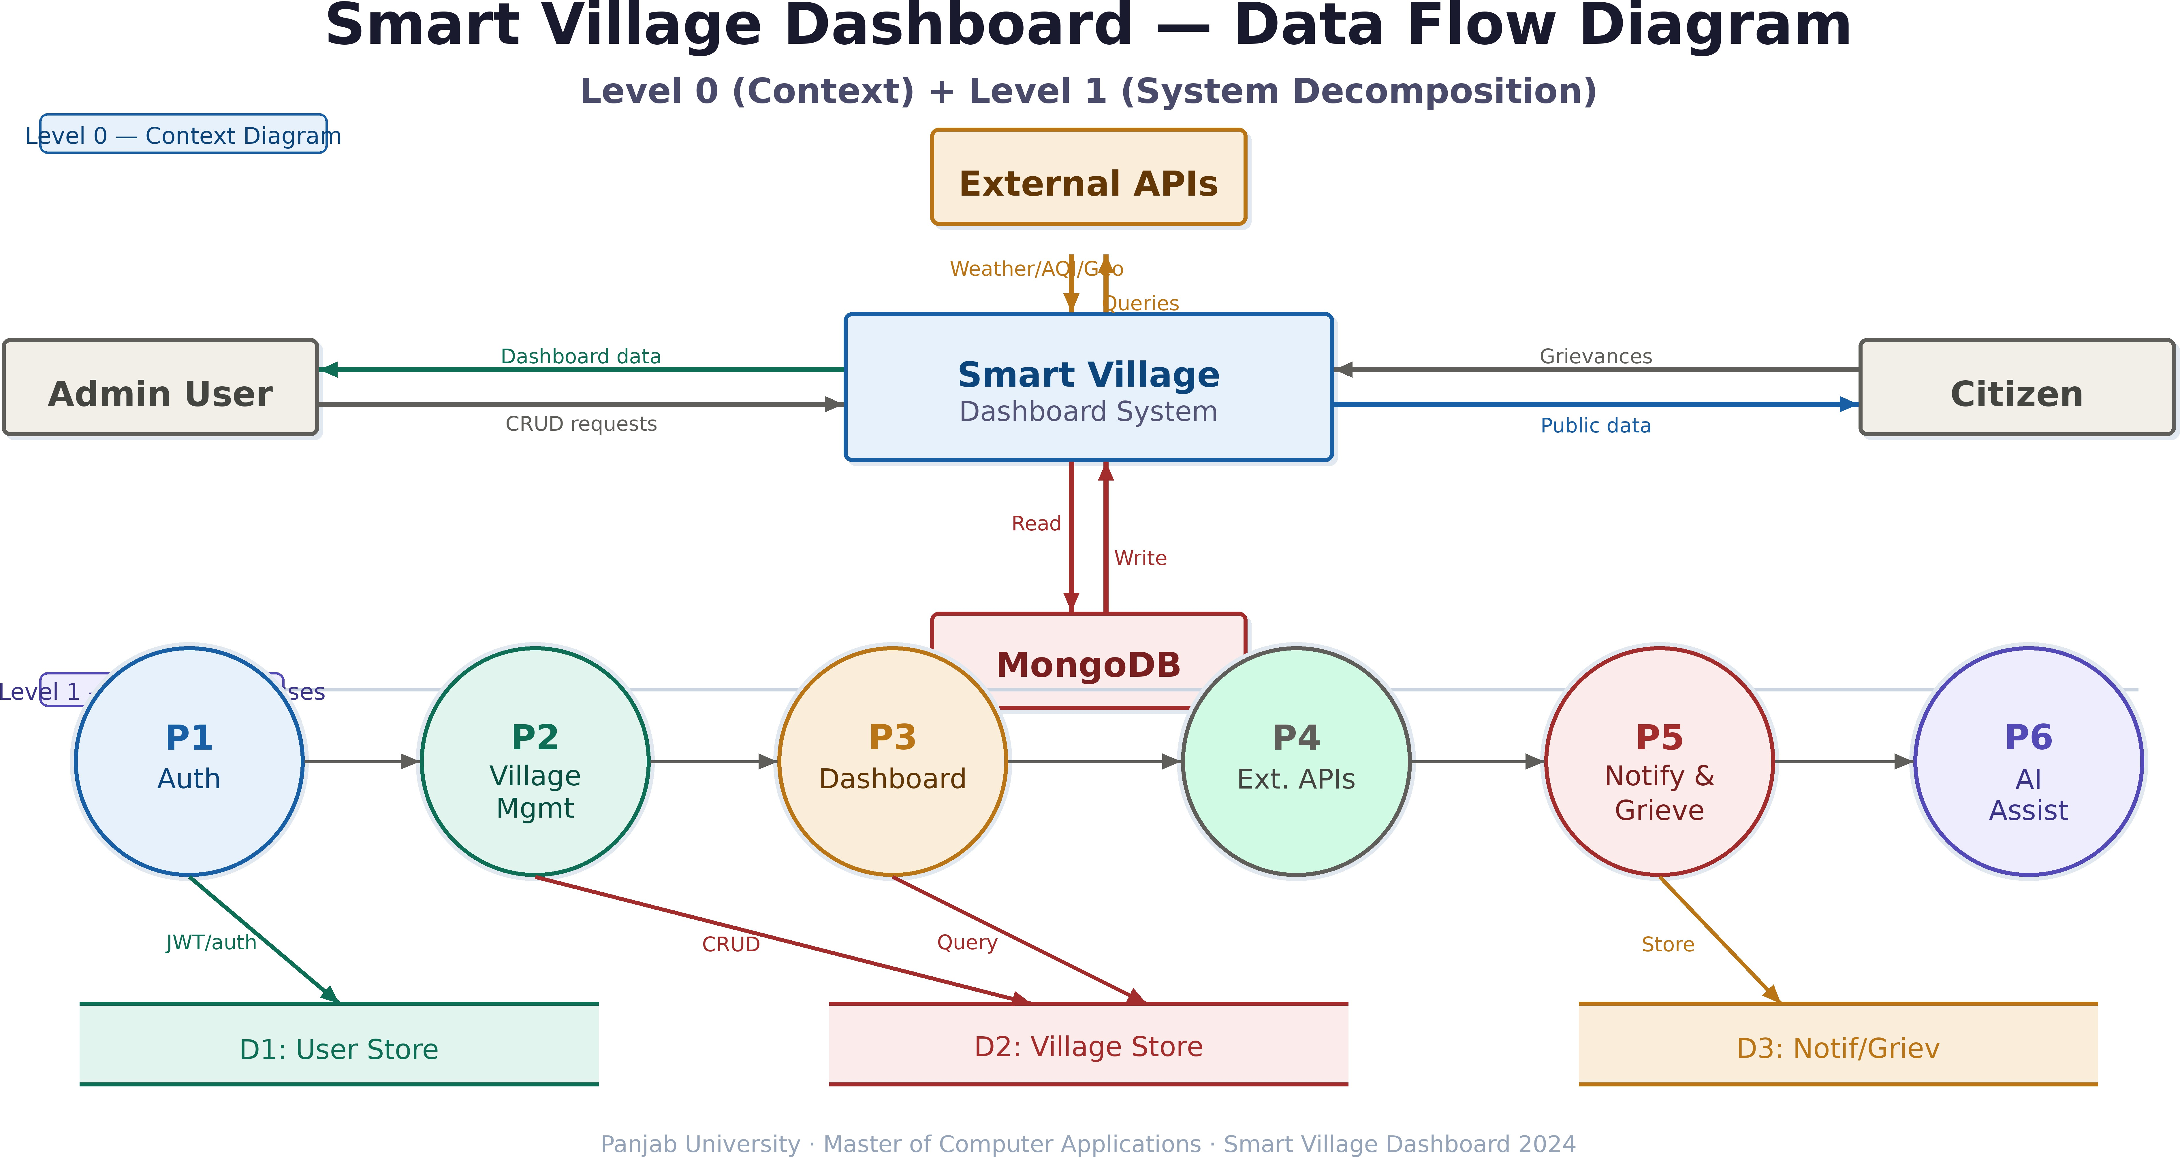

Fig. 3. Data Flow Diagram (Level 0 and Level 1) showing complete system data movement.

A. Runtime Execution Flow
The runtime sequence follows a unidirectional data flow pattern:
- The browser loads index.html from the web server.

- main.js executes and mounts the React application into #root.
- App.js evaluates the URL path and renders the corre- sponding page component.
- AppLayout.js renders the common UI skeleton sur- rounding the page content.
- Page components consume state from DataContext
or AuthContext.
- Context modules invoke client.js (Axios API client) to make HTTP requests.
- The API client attaches a JWT token from
localStorage to request headers.
- Requests are sent to /api/* endpoints on the Express server.
- Express routes forward requests to controller functions.
- Controllers perform CRUD operations on MongoDB via Mongoose models.
- Response data propagates back through the same chain to update the UI.

Browser→index.html→main.js→App.js→AppLayout.js
→ Page→Context→apiClient→ /api/∗
→ Express→Controller→Mongoose→MongoDB
TABLE II
Reusable Component Inventory

Component Purpose

PageBanner.js Consistent page header across routes
ChartCard.js Chart.js visualization wrapper
VillageCard.js Village summary display
StatCard.js Key performance indicator
DataTable.js Reusable tabular layout SearchToolbar.js Search and filter bar AssistantWidget.js Floating AI chat interface WeatherSpotlight.js Live weather display AirQualitySection.js Air quality index display

TABLE III
API Endpoint Groups

Endpoint | Route File | Purpose
/api/auth | authRoutes.js | Login, signup, pro- file
/api/villages | villageRoutes.js | Village CRUD ops
/api/dashboard | dashboardRoutes.js | Analytics & trends
/api/notifications | notificationRoutes.js | Platform alerts
/api/locations | locationRoutes.js | Place search
/api/assistant/queryassistantRoutes.js AI chat responses

- Frontend Subsystem
- Routing and Layout Management
(1)
VII. External API Integrations
The system consumes three external live APIs:
1) Open-Meteo Geocoding API: Converts place names to geographic coordinates. Integrated in

App.js functions as the central route registry, mapping URL paths to page components including Landing, Dash- board, Analytics, Growth, Search, Contact, Admin, and others. AppLayout.js provides persistent UI elements across all authenticated routes.
- State Management Contexts
Two React contexts manage application state:
DataContext: Loads and manages villages, dashboard overview metrics, temporal trend data, and system notifica- tions.
AuthContext: Handles login, signup, logout, JWT storage in localStorage, and controls the first-visit authentication modal.
- API Communication Layer
client.js implements an Axios-based API gateway. It automatically intercepts outgoing requests and attaches the JWT token to the Authorization header.
- Reusable Component Library
Table II lists components designed for reuse across multiple pages.
- Backend API Endpoints
All routes are mounted under the /api prefix. Table III summarizes the available endpoint groups.
locationController.js (backend).
- Open-Meteo Forecast API: Retrieves current and forecasted weather. Consumed by WeatherSpotlight.js (frontend).
- Open-Meteo Air Quality API: Provides the Air Quality
Index. Consumed by SearchFilterPage.js (fron- tend).
Note: The system does not integrate any live Delhi Metro API. Metro-related content is static growth-domain informa- tion.
VIII. Functional Features

TABLE IV
Complete Functional Feature Set

Feature Description

Authentication Role-based (Admin/User) with JWT Landing Page Hero carousel, village cards, weather, AQI Village Intelligence Growth, literacy, water, soil, infrastructure
data
Admin Control Create/update villages, real-time propaga-
tion
Analytics Charts, summary cards, trends, schemes
Search Real place search with governance dash- board
Notifications Admin-published platform-wide alerts AI Assistant Floating widget for page guidance Grievance System Citizen complaint submission
Theme Dark/light mode, responsive layout

IX. Conclusion and Future Work
This paper presented the Smart Village Dashboard, a com- prehensive governance intelligence platform built on a four- layer architecture. The system was successfully developed by a team of five MCA students at Panjab University with distinct responsibilities spanning frontend, backend, database, API integration, and UI/UX.
The platform demonstrates successful integration of role- based authentication, real-time data propagation, external en- vironmental APIs, and a reusable component library. It enables administrators to manage village intelligence while providing citizens transparent access to analytics, weather data, and grievance mechanisms.
Future work includes:
- IoT sensor integration for real-time soil and water mon- itoring.
- Predictive analytics for agricultural yield forecasting.
- Mobile application for offline access in low-connectivity regions.
- Multi-language support for regional language accessibil- ity.
- Government scheme API integration for subsidy tracking.
Acknowledgment
The authors thank their project guide and the Department of Computer Applications, Panjab University, Chandigarh, for their continuous guidance and support throughout the development of the Smart Village Dashboard.
References
- A. B. Smith and C. D. Johnson, “Smart village frameworks for sus- tainable development,” IEEE Trans. Sustain. Comput., vol. 8, no. 2,
pp. 112–125, 2023.
- React Documentation, “React component architecture,” Meta Open Source, 2024. [Online]. Available: https://react.dev
- Express.js Team, “Express API reference,” OpenJS Foundation, 2024.
- MongoDB Inc., “MongoDB manual,” 2024.
- Open-Meteo, “Open-Meteo weather API documentation,” 2024.
- JWT.io, “JSON Web Token introduction,” Auth0, 2024.

